Clinical Pathophysiology I · Exam 1 — Study Guide
Editable Word copy of the PA_Quizzes study aid. Headings use real Word styles, so the navigation pane and the contents field below both work, and restyling one heading restyles them all.
[In Word: right-click here and choose Update Field to build the contents.]

1 · Inflammation
INSTRUCTIONAL OBJECTIVES
- Describe the molecular mechanisms of inflammatory processes
- Describe the various types and etiologies of inflammation
- Compare and contrast the mechanism of white blood cells in the inflammatory response
- Describe the vascular changes associated with acute inflammation
- Describe the cellular changes associated with acute inflammation
- Compare and contrast mediators of inflammation and their functions

NOTE
Objective (d) wording. The syllabus says vascular changes; the slide says vascular effects. The syllabus wording is the one used here and on the exams.

1.1 · Objective a — Molecular mechanisms of inflammatory processes
Inflammation is the reaction of vascularized living tissue to injury. The word vascularized is doing real work in that definition — tissue without a blood supply cannot mount the response at all. The process is a sequence of events that heals the injury or implant site, either by generating new tissue from native parenchymal cells or by forming fibroblastic scar tissue.
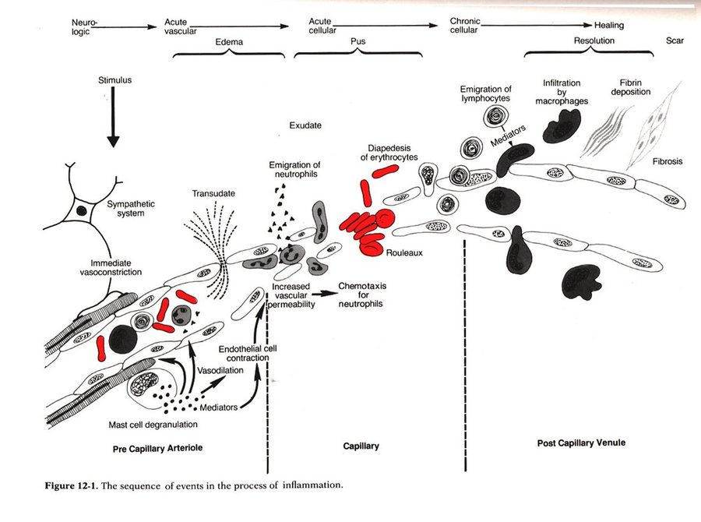
The single most useful figure in this lecture, because it puts every objective on one timeline. Read it left to right: immediate vasoconstriction at the arteriole, then mediators from mast cell degranulation driving vasodilation and endothelial cell contraction, then increased vascular permeability producing transudate and exudate, then chemotaxis and emigration of neutrophils, and only later the lymphocytes and macrophages of the chronic phase, ending in fibrin deposition, fibrosis and scar. Note the vertical divisions: the vascular events happen at the arteriole and capillary, while the cellular emigration happens at the post-capillary venule — the anatomy changes as the response progresses, which is why objectives (d) and (e) are separated in the first place. Figure 12-1, reproduced from the lecture slides (Slide 13).
The five main processes, in order:
# | Process
I | Increased blood flow
II | Increased permeability
III | Migration of neutrophils
IV | Chemotaxis
V | Leucocyte recruitment & activation

The three vascular mechanisms are a causal chain, not a list: vasodilation of the arterioles raises blood flow → endothelial contraction opens the capillaries to increased permeability → exudation, fluid and blood proteins moving into the interstitial spaces. Each step is what makes the next possible, which is why the order is examinable.

1.2 · Objective b — Types and etiologies of inflammation
 | Acute | Chronic
Timescale | Seconds, minutes, hours or days — begins within seconds of injury | Longer — days, weeks, months
Histology | Neutrophil-predominant exudate | White blood cells (lymphocytes and macrophages), proliferation of blood vessels, fibrosis, tissue necrosis
Nature of damage | May be purely physical, or may involve activation of an immune response (trauma versus a bee sting) | Driven by persistence rather than by the initial insult

The three causes of chronic inflammation, each with the lecture's own examples:
Cause | Examples
Persistent infection | Bacteria, viruses, fungi, parasites
Prolonged exposure to potentially toxic agents | Endogenous — atherosclerosis · Exogenous — particulates such as silica
Autoimmunity | Rheumatoid arthritis, lupus

1.3 · Objective b — Patterns of inflammation
Chronicity and pattern are two independent axes. A process is acute or chronic, and separately shows one of these patterns:
★ PROFESSOR EMPHASIS
★ Professor emphasized
Pattern | What defines it
Serous | Largely plasma, low protein; occurs early or with mild inflammation
Fibrinous | Large amounts of fibrinogen forming a thick meshwork; removable only by fibrolytic enzymes — failure of that results in scar tissue formation
Suppurative (purulent) | Remnants of white blood cells, protein and tissue debris — that is, pus
Hemorrhagic | Damage to blood vessels; occurs alongside other exudates
Catarrhal | Mucus hypersecretion accompanying inflammation of a mucous membrane
Ulcerative | Necrosis and sloughing of surface epithelium, exposing underlying connective tissue
Pseudomembranous | Superficial necrotic layer of fibrin, inflammatory cells and debris forming a membrane-like covering over the affected mucosa
Gangrenous | Severe necrosis with or without superimposed bacterial infection — dry is coagulative necrosis, wet is liquefactive necrosis from infection

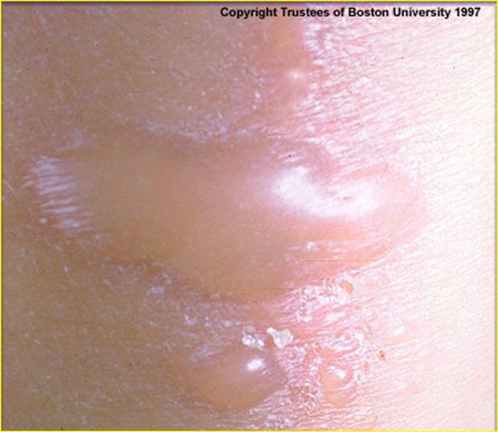
Serous. A skin blister. Clear, low-protein plasma has collected beneath the epidermis — the thin watery fluid is the whole identity of this pattern, and it is what mild or early inflammation produces before protein and cells follow. Copyright Trustees of Boston University 1997; reproduced from the lecture slides (Slide 8).
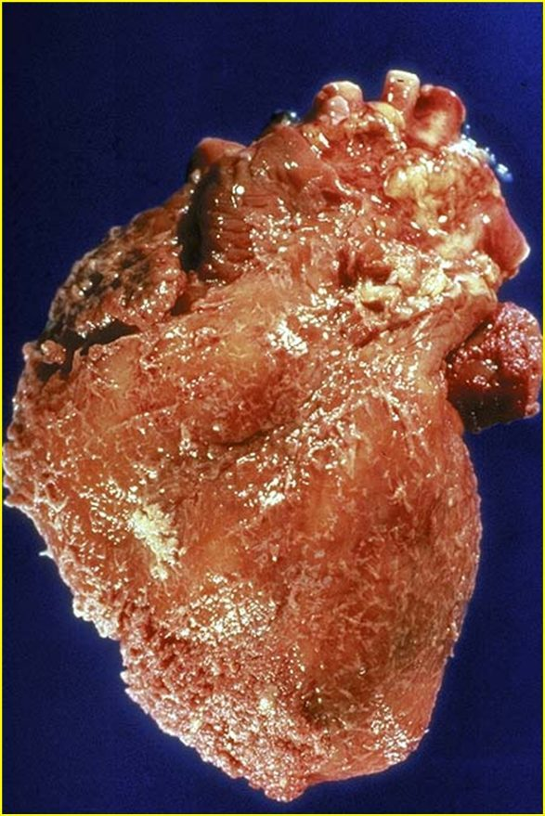
Fibrinous. A heart with a rough, shaggy epicardial surface instead of its normal glistening one. That texture is fibrin, laid down from the large amounts of fibrinogen this pattern exudes. Only fibrolytic enzymes can clear it — and where they fail, this is the surface that heals to scar. Reproduced from the lecture slides (Slide 8).
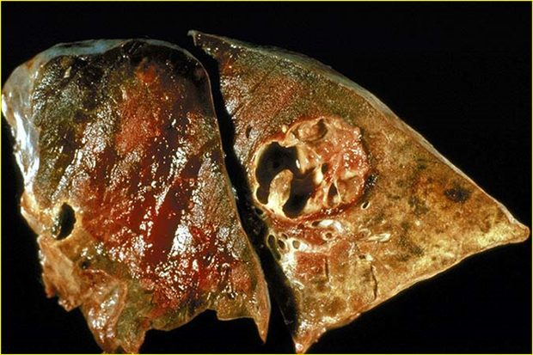
Suppurative (purulent). Lung with a cavitating abscess. The cavity contains the remnants of white blood cells, protein and tissue debris — pus — and it exists because neutrophils cannot renew their lysosomes and die in bulk at the site. Reproduced from the lecture slides (Slide 9).
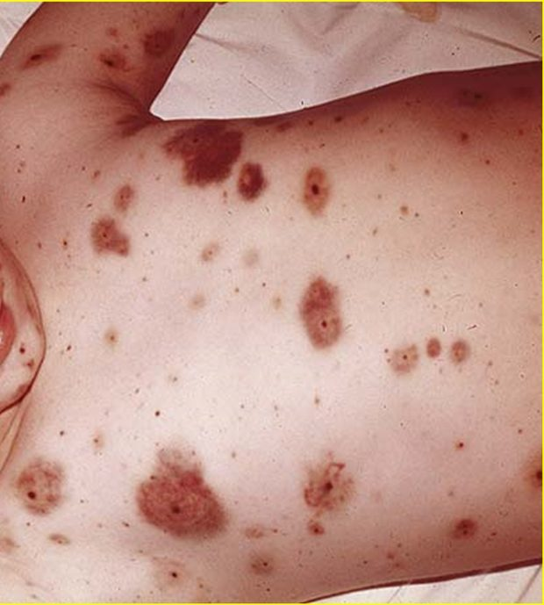
Hemorrhagic. Purpuric lesions across the trunk. Blood has escaped the vessels into the tissue, which is what damage to blood vessels looks like clinically; the lecture notes this pattern occurs alongside other exudates rather than instead of them. Cropped to the lesions — the source photograph shows an identifiable child. Reproduced from the lecture slides (Slide 9), cropped.
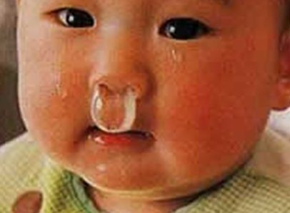
Catarrhal. Copious clear nasal discharge. Mucus hypersecretion accompanying inflammation of a mucous membrane — the most familiar pattern on this list, and the only one most people have watched happen to themselves. Cropped to the finding; the source photograph shows an identifiable infant. Reproduced from the lecture slides (Slide 9), cropped.
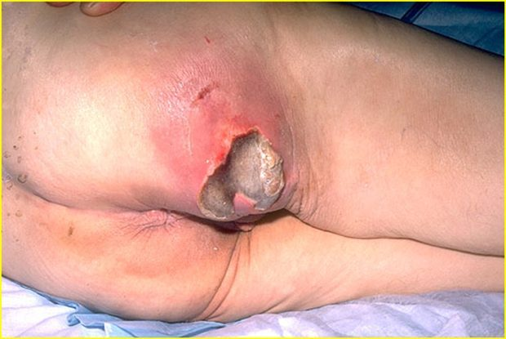
Ulcerative. A sacral pressure ulcer. The surface epithelium has undergone necrosis and sloughed, exposing the connective tissue beneath — this pattern REMOVES a layer, which is the distinction from pseudomembranous below. Reproduced from the lecture slides (Slide 10).
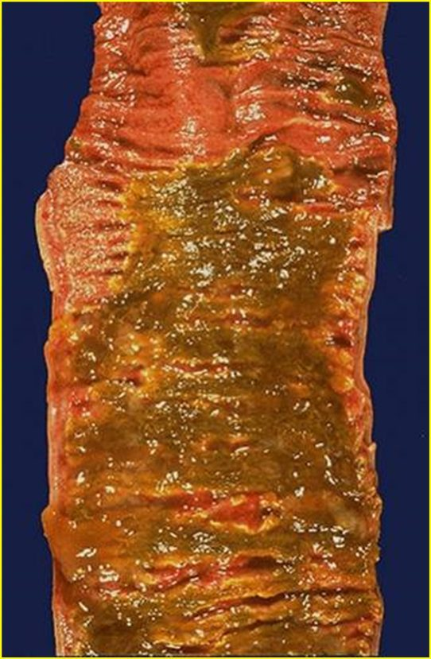
Pseudomembranous. Colon carpeted in a yellow-green adherent membrane. A superficial necrotic layer of fibrin, inflammatory cells and debris has formed OVER the mucosa — this pattern ADDS a layer, the mirror image of the ulcer above. Putting the two side by side is the fastest way to stop confusing them. Reproduced from the lecture slides (Slide 10).
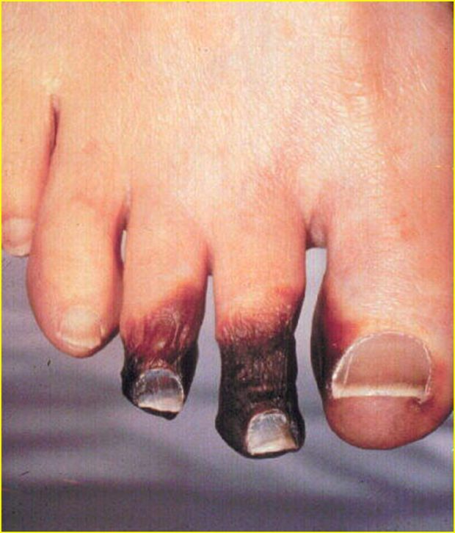
Gangrenous (dry). Mummified, blackened toes with a sharp line against viable skin. Dry gangrene is coagulative necrosis — the tissue desiccates rather than liquefying, which is what separates it from wet gangrene, where superimposed infection produces liquefactive necrosis instead. Reproduced from the lecture slides (Slide 10).
Ulcerative versus pseudomembranous is the pair most often confused, and the distinction is directional: ulcerative removes the surface and exposes what is beneath; pseudomembranous adds a layer on top of the mucosa.

1.4 · Objective c — Mechanism of white blood cells
 | Granulocytes (polymorphonuclear, PMN) | Agranulocytes (mononuclear)
Defining feature | Differently staining granules in the cytoplasm on light microscopy — membrane-bound enzymes that digest phagocytized particles | Apparent absence of granules — though they do contain non-specific azurophilic granules (lysosomes)
Members | Neutrophils, basophils, eosinophils | Lymphocytes (B and T cells), monocytes, macrophages

Note the terminology trap: PMN refers to all granulocytes, not to neutrophils alone, even though neutrophils are the ones usually meant in conversation.
Cell | Nucleus & granules | Role
Neutrophil | Multilobed nucleus that may look like multiple nuclei; cytoplasm appears transparent from fine pale lilac granules | First responder to microbial infection; bacterial and fungal defence; very active phagocyte. Cannot renew its lysosomes, so dies after a few pathogens — their death in large numbers forms pus
Basophil | Bi- or tri-lobed nucleus; coarse granules | Allergic and antigen response via histamine
Eosinophil | Bi-lobed nucleus; granules a characteristic pink-orange | Parasitic infections; predominant cell in allergic reactions — asthma, hay fever, hives
B lymphocyte | Agranulocyte | Humoral immunity: makes antibodies, acts as antigen-presenting cell, becomes memory B cells. Essential to adaptive immunity
T lymphocyte | Matures in the Thymus; carries T cell receptors | Cell-mediated immunity (subsets below)
Monocyte | Kidney-shaped nucleus; abundant, usually agranulated cytoplasm | Phagocytoses then presents pathogen fragments to T cells; leaves the bloodstream to become a tissue macrophage. Can replace its lysosomal contents

NOTE
The neutrophil/monocyte contrast is the point of objective (c). Both phagocytose. The neutrophil cannot renew its lysosomes and dies after a few pathogens, which makes it a disposable first responder and explains pus. The monocyte can replace its lysosomal contents and keeps working, which is why it is the cell of the sustained, chronic phase.

T cell subset | Function
T helper cells | Activate and regulate T and B cells
CD8+ cytotoxic T cells | Virus-infected and tumour cells
Regulatory (suppressor) T cells | Return immune function to normal after infection; prevent autoimmunity
Natural killer cells | Virus-infected and tumour cells

1.5 · Objective d — Vascular changes in acute inflammation
The reviewed sequence opens with four vascular events, in this order:
1 | Vasoconstriction
2 | Vasodilation
3 | Increased vascular permeability
4 | Haemoconcentration and stasis

Vasoconstriction coming first catches people out, since the visible signs of inflammation are all dilation. Note also why stasis matters mechanistically: slowed flow is what lets leukocytes reach and stay against the endothelium, so it is the hinge between the vascular and cellular halves of the response.

1.6 · Objective e — Cellular changes in acute inflammation
The sequence continues with five cellular events:
5 | Leukocyte adhesion
6 | Transmigration
7 | Chemotaxis
8 | Aggregation
9 | Phagocytosis

Acute inflammation in review: short term (minutes to days), with exudation of fluid, plasma, proteins and leukocytes (neutrophils), then phagocytosis and enzymatic release. Activated neutrophils and macrophages digest foreign material through four steps — recognition, attachment, engulfment, degradation — and recognition and attachment are enhanced when serum factors (opsonins) are present.
Chronic inflammation in review: long term (at least days), characterised by macrophages, monocytes and mononuclear cells including lymphocytes and plasma cells, accompanied by proliferation of blood vessels and connective tissue. Lymphocytes and plasma cells mediate antibody production; macrophages process and deliver antigen to immunocompetent cells.

1.7 · Objective f — Mediators of inflammation and their functions
Mediator | Function
Histamine | First mediator of the initial inflammatory response. Dilates arterioles and increases permeability of capillaries and venules
Serotonin | Vasodilation and increased vascular permeability
Bradykinin | Increases capillary permeability, causes pain, and may increase leukocyte chemotaxis
Complement components | 10% of circulating serum proteins; chemotactic to neutrophils and monocytes; the cascade may damage bacteria
Coagulation system | Creates a fibrous network at the site to trap exudate, microorganisms and foreign bodies, and stops bleeding so repair can begin

Histamine, serotonin and bradykinin all raise permeability. Only bradykinin causes pain — that is the discriminating feature if a question gives you the effects and asks for the mediator.
Opsonins are proteins that adhere to foreign material and make it easier for immune cells to recognise and attach to it.
★ PROFESSOR EMPHASIS
★ Professor emphasized
Opsonin | What it is | Recognised by
Immunoglobulin G (IgG) | An antibody | Fc receptors on macrophages and neutrophils, which recognise the Fc portion
Complement fragment C3b | Produced when the complement system is activated; binds microorganisms or foreign material | Complement receptors on immune cells

NOTE
Clinical application worth remembering. A biomaterial — anything not human put into a human — becomes coated with immunoglobulin G and C3b. Immune cells recognise that coating and attach to the material, which is why an implanted medical device can provoke an inflammatory response even when it is completely sterile. The response is to the opsonised surface, not to infection.

Source: 1. Inflammation.pptx (Professor Lauren Reynolds), Slides 1–35, and the PAJ 5101 syllabus instructional objectives. Course text: Robbins & Cotran Pathologic Basis of Disease, 10th edition — Chapter 3, “Inflammation and Repair”.

2 · Dermatology: Pathophysiology of the Skin
Stacie Gopal, DMS, PA-C
INSTRUCTIONAL OBJECTIVES
- Review the anatomy of the integumentary system, including the different strata of the integument
- Compare and contrast pathophysiology of common primary skin lesions
- Compare and contrast pathophysiology of common secondary skin lesions
- Describe the molecular mechanisms of common dermatological conditions

NOTE
The line between this course and Clinical Medicine and Surgery I. Dermatology is taught in both this term, and the same diseases appear in each. The split is that this course asks what is happening in the tissue and why — which cell, which pathway, which layer — while Clinical Medicine and Surgery I asks how you recognise it and what you do about it. If a fact would sit equally well in both, it is probably pitched for the other one.

2.1 · Objective a — Anatomy of the integumentary system
Skin is the largest organ in the body, with hair, nails and glands as accessory structures. Its functions are a physical barrier against pathogens, ultraviolet light, fluid loss and trauma; thermoregulation; sensation; and an endocrine role.
The vitamin D chain crosses three organs. Cholecalciferol (vitamin D3) is produced in the skin under ultraviolet B light, then hydroxylated first in the liver and then in the kidneys to the active form calcitriol. The skin only starts the process.
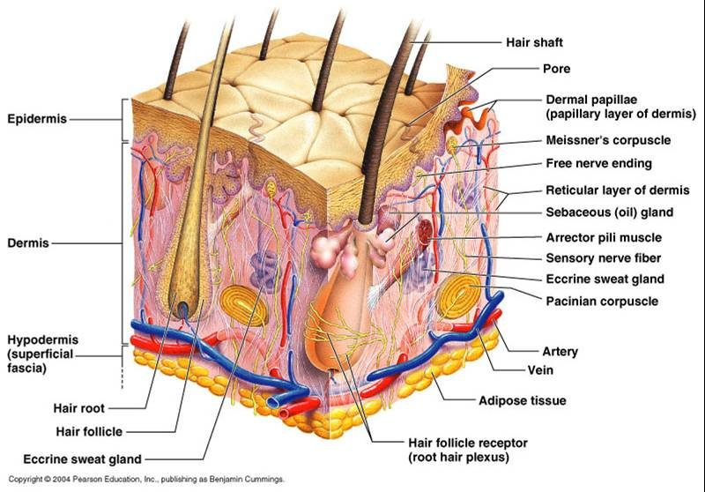
The whole of objective (a) in one block. Read it top to bottom: epidermis, then the dermis split into papillary above and reticular below, then hypodermis. Nearly everything that matters for the rest of this section is visible here — the appendages that produce sebum and sweat, the two named mechanoreceptors, and the vessels that sit in the dermis rather than the epidermis. That last point carries a lot of weight later: the epidermis has no blood supply of its own, which is why a lesion confined above the dermal-epidermal junction cannot bleed and cannot scar. © 2004 Pearson Education, Inc., publishing as Benjamin Cummings. Reproduced from the lecture slides (Slide 5).
Three layers: epidermis, dermis and subcutaneous (hypodermis). The dermis is where the nerves and vasculature sit.
★ PROFESSOR EMPHASIS
★ Professor emphasized
There is no vasculature in the epidermis. She said this in the first thirty seconds and told the class to carry it through the whole lecture: “do keep that in mind … it’s important for you to remember … that will help you differentiate things as we go.” It is the reason an erosion cannot bleed and cannot scar while an ulcer can, and the reason the dermal-epidermal junction is the boundary that matters in half the definitions below.

The epidermis
Stratified squamous epithelium, 0.05 to 1.5 mm, with four cell types — keratinocytes (about 90%), melanocytes, Merkel cells and Langerhans cells. Turnover is every 30 to 60 days and is more rapid in younger patients.
★ PROFESSOR EMPHASIS
★ Professor emphasized
Keratinocytes are about 90% of the epidermis, and keratin is the recurring theme. “That’s important to remember, because they produce keratin, and as we walk through the pathophysiology of the skin today you’re going to hear keratin over and over and over again.” It duly reappears below in hyperkeratosis, the epidermal inclusion cyst, the fissure and lichenification. This was also the one point the prosody analysis independently flagged.

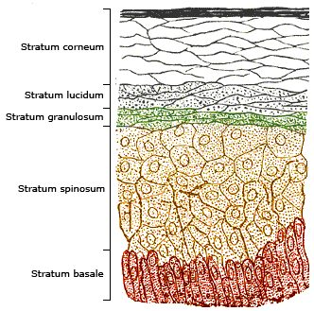
The five strata in order, and the order is the point: cells are born at the bottom and are dead by the top. Division happens only in the basale; the spinosum is where desmosomes give the prickle-cell appearance; the granulosum holds the keratohyalin granules; and the corneum is 20 to 30 layers of dead keratinocytes cemented into the barrier. Psoriasis is easier to remember against this picture — it is the loss of the granular layer that leaves the scale. Reproduced from the lecture slides (Slide 9).
Stratum | What defines it
Basale (deepest) | Single layer of rapidly dividing columnar keratinocytes — the site of cell division. Contains melanocytes and Merkel cells (light touch)
Spinosum | 8–10 layers joined by desmosomes, giving the prickle-cell appearance. Contains dendritic and Langerhans cells, the immune sentinels
Granulosum | 3–5 layers of diamond-shaped cells containing keratohyalin granules
Lucidum | 2–3 layers of flattened dead keratinocytes with clear protein and lipids
Corneum (outermost) | 20–30 layers of keratin and dead keratinocytes, packed and cemented into a semi-impermeable barrier

The dermis and the appendages
Two connective tissue layers: papillary (thin, superficial) and reticular (dense, deeper). Collagen is the primary component, produced by fibroblasts, giving tensile strength; elastic fibres of elastin and fibrillin give recoil. Cells include fibroblasts, macrophages, histiocytes, adipocytes and mast cells, which mediate immunoglobulin E-driven inflammation.
★ PROFESSOR EMPHASIS
★ Professor emphasized
Where the mast cells live. Flagged twice — “it’s important to remember that this is where our mast cells are located, because we’ll be talking about mast cells a lot later in the pathophysiology”, then again on the next slide, “make note of that too”. They sit in the dermis, and they are the mechanism behind the wheal.

Appendage | Secretion and function
Eccrine sweat glands | Open onto the skin surface; water and electrolytes (sodium, chloride); cooling by evaporation
Apocrine sweat glands | Axilla and anogenital areas; protein and fatty lipids; scent glands. Apocrine sweat + bacterial degradation = body odour
Sebaceous glands | Sebum — triglycerides, wax esters, squalene — lubricating skin and hair

Hair comes in three types: terminal (thick, androgen-regulated), lanugo (fine, newborn) and vellus (fine, short, growth independent of androgens).

2.2 · Objective b — Primary skin lesions
A primary lesion is the direct result of the underlying disease and retains its original, unmodified appearance. Read the table by mechanism rather than by name — the size cut-offs are arbitrary, but what is happening in the tissue is not.
Lesion | Size | What is happening in the tissue
Macule | ≤ 5 mm | Flat, circumscribed discoloration, NOT palpable. Hyperpigmented from increased melanin in the basal layer; hypopigmented from loss of melanocytes (vitiligo)
Patch | > 5 mm
Papule | < 5 mm | Epidermal hyperplasia with hyperkeratosis, plus inflammation and dense collagen in the dermis
Nodule | > 5 mm | Dermal-based, dense collagen bundles, extending into subcutaneous tissue
Plaque | > 1 cm | Confluence of papules, with marked epidermal thickening and dilated dermal vessels
Vesicle | ≤ 5 mm | Fluid with inflammatory cells collecting within or directly beneath the epidermis
Bulla | > 5 mm | Separation of epidermis from dermis with fluid accumulation — a deeper plane of cleavage, not just a bigger vesicle
Wheal | transient | Mast cells release histamine → vasodilation and vascular permeability → plasma leaks into dermis; histamine also acts on cutaneous nerve endings to cause pruritus
Pustule | ≤ 1 cm | Purulent material — leukocytes, debris, serous fluid, possibly organisms. Usually Gram-positive (Staphylococcus aureus, Streptococcus pyogenes); may be sterile, as in rosacea
Cyst | — | Encapsulated, in dermis or subcutis. Epidermal inclusion cyst arises from a hair follicle and contains keratin
Tumor | > 2 cm | General term for rapid cellular growth, benign or malignant — “tumor by itself doesn’t mean malignant”. Dermatofibroma is benign fibrous overgrowth; lipoma is an enclosed capsule of adipocytes

One discriminator does most of the work: macules and patches are not palpable; papules, nodules and plaques are. Everything else follows from depth and content.
★ PROFESSOR EMPHASIS
★ Professor emphasized — exam scope
She addressed the size cut-offs directly, and told the class how they will be tested. Sources disagree — many define a macule as up to one centimetre rather than five millimetres, and the Physical Diagnosis II deck does exactly that.
“For our sake of this lecture and testing, I’m going to define it up to five millimetres … if you’re reading it in other sources and it goes up to one centimetre, don’t be alarmed.” And twice: “it’s not gonna be a gotcha thing on the exam, I promise you … do know the general range. The macules are smaller, the patches are bigger.”
So the table above uses her numbers, which are the ones this exam will use. Know the numbers — they are fair game. What she will not do is hinge a question on a borderline value. Learn the boundaries; do not agonise over the edge cases.

2.3 · Objective c — Secondary skin lesions
A secondary lesion is a primary lesion modified over time by infection, trauma or other factors, and it may or may not still resemble what it came from.
Lesion | What is happening in the tissue
Scale | Compact portion of desquamating stratum corneum (psoriasis)
Crust | Dried sebum, cellular debris, blood or necrotic skin (impetigo)
Lichenification | Thickened epidermis from long-term scratching — the itch-scratch cycle. Hyperplasia and hyperkeratosis; thick plaques without scaling (lichen simplex chronicus)
Erosion | Focal loss of epidermis that does not penetrate below the dermal-epidermal junction
Ulcer | Focal loss of epidermis and dermis, with destruction of collagen and infiltration of inflammatory cells
Fissure | Linear ulcer forming a crack, from loss of elasticity, severe dryness and mechanical tension, with hyperkeratosis
Atrophy | Thinning: keratinocyte division slows, collagen synthesis slows, elastin degrades

NOTE
Why an ulcer scars and an erosion does not. The dermal-epidermal junction is the boundary. An erosion stays above it, so the dermis and its collagen are untouched and there is nothing to repair with scar. An ulcer crosses it and destroys collagen, so healing has to lay down new collagen — and that is what a scar is.

2.4 · Objective c — Wound healing and scar
Phase | Days | What happens
Inflammatory | 1–3 | Fibrin haemostatic plug; neutrophils and macrophages remove dead tissue; growth factors and cytokines signal the next phase to begin
Proliferative | 4–21 | Granulation tissue forms — macrophages, fibroblasts and endothelial cells
Remodelling | 21 – 1 year | Granulation tissue formation ceases. Type III collagen is replaced with stronger type I, oriented in small parallel bundles — where normal dermis has a basket-weave orientation

The lecture marks remodelling as the important phase, and the collagen swap is why: the scar ends up strong but architecturally different from the skin around it, which is why it never quite matches.
★ PROFESSOR EMPHASIS
★ Professor emphasized
Granulation tissue must stop forming after the proliferative phase. “The formation of granulation tissue should cease at this stage, so that’s important to notice. We should not be producing granulation tissue outside of the proliferative phase.”
A student then asked what happens when it does not cease, and Professor Gopal called it “a great question … this is exactly where we’re at”: fibroblast dysregulation prolongs the proliferative phase, collagen is laid down abundantly and haphazardly, and it exceeds the boundaries of the original wound — giving hypertrophic scars and keloids. She added that keloids are especially common in darker skin tones, and that trauma as minor as an ear piercing can produce one.

Hypertrophic scars and keloids are two failures, not one. Fibroblast dysregulation prolongs the proliferative phase, and deposition and degradation become imbalanced during remodelling. Collagen bundles then develop haphazardly and exceed the boundaries of the initial wound — which is the defining feature.

2.5 · Objective d — Molecular mechanisms of common conditions
★ PROFESSOR EMPHASIS
★ Professor emphasized
Allergic contact dermatitis is a delayed hypersensitivity reaction. “The important thing to remember about allergic contact dermatitis is that it’s a delayed hypersensitivity reaction, and it develops after you have an initial exposure and then you’re re-exposed to it.” She walked both phases by name: sensitization, where Langerhans cells present haptens — the nickel or the poison ivy — to T cells and build memory, then elicitation on re-exposure. Contrast it with irritant contact dermatitis in the row below, which needs no prior exposure at all. That pairing is the discrimination worth holding.

Condition | Mechanism
Petechiae / purpura / ecchymoses | Bleeding into the dermis from capillary rupture, infection, thrombocytopenia or vasculitis. Same pathology at three sizes: ≤1–2 mm, 3–10 mm, >10 mm. Non-blanchable. Henoch-Schonlein purpura is an immunoglobulin A vasculitis of skin, joints, kidneys and intestines, commonly aged 3–10
Telangiectasia | Permanent dilatation and thinning of endothelium of superficial dermal vessels, with no inflammatory cell infiltration
Urticaria | Mast cell degranulation releasing histamine, forming wheals
Allergic contact dermatitis | Delayed hypersensitivity, 48–72 hours. Sensitization: Langerhans cells present haptens to T cells, creating memory. Elicitation: re-exposure promotes T cell migration and cutaneous inflammation (nickel, poison ivy)
Irritant contact dermatitis | Direct cutaneous interaction with a chemical, biologic or physical agent — does not require prior exposure
Eczema (atopic dermatitis) | T cell-mediated. Overactive immune system plus insufficient filaggrin from a compromised epidermal barrier, with genetic, environmental and psychogenic factors. “The itch that rashes”
Neurodermatitis | Cause unknown; nerve hypersensitivity suspected. Itch-scratch cycle producing thick, leathery, scaly plaques
Seborrhoeic dermatitis | Cause incompletely understood. Microbiome dysbiosis, altered immune response and barrier dysfunction, in sebaceous-rich regions. Dandruff is the non-inflammatory form
Seborrhoeic keratosis | Benign proliferation of immature keratinocytes; possibly activating mutations in fibroblast growth factor receptor-3
Actinic keratosis | Cumulative ultraviolet damage → intraepidermal proliferation of dysplastic keratinocytes. The most common precancer; higher risk for squamous cell carcinoma
Psoriasis | Chronic autoimmune inflammatory dermatosis; cells multiply up to 10× faster. Active T cells infiltrate the epidermis and stimulate keratinocyte proliferation with tumour necrosis factor alpha, interferon gamma and interleukin-12. Epidermal hyperplasia, loss of the stratum granulosum, and failure to secrete lipids (xeroderma)
Verrucae vulgaris | Human papillomavirus invades epidermal basal cells through microabrasions, driving epidermal proliferation
Dermatophyte infection | Trichophyton, Microsporum, Epidermophyton. Spores secrete keratinases and proteases to digest keratin, typically in the stratum corneum — hence the annular patch with central clearing

★ PROFESSOR EMPHASIS
★ Professor emphasized
Psoriasis, in one sentence. “We could probably do an entire lecture on psoriasis alone — today the focus is really just the underlying pathophysiology … the important thing to understand about psoriasis is that it’s a chronic autoimmune inflammatory condition that causes rapid proliferation of cellular growth.”
She noted you will meet it again in your other courses, which is the mechanism-not-management line this class runs on. Findings she named: well-demarcated patches with a characteristic silvery scale, anywhere but often the elbows, knees, scalp and lower back.

Nails
Finding | Mechanism
Leukonychia (Mee’s lines) | Temporary incomplete keratinization at the nail bed; usually harmless, but also heavy metal poisoning
Koilonychia | Impaired keratin synthesis, associated with deficiency anaemia; thin, concave, ridged
Beau’s lines | Halt of keratin production — transverse grooves. Illness, stress, injury, malnourishment
Terry’s nails | Overgrowth of connective tissue in the nail bed. Aging, liver disease, congestive heart failure, diabetes
Clubbing | Increased capillary density with increased release of vascular endothelial growth factor. Lung, inflammatory bowel, cardiovascular and liver disease

2.6 · Objective d — Skin cancers
Cancer | Mechanism and behaviour
Basal cell carcinoma | Most common skin cancer and most common malignancy in humans. Ultraviolet-induced mutation of basal keratinocytes overactivating the Hedgehog signalling pathway. Head and neck; slow growing, rarely metastasises. Pearly papules with telangiectasias
Squamous cell carcinoma | Second most common. Ultraviolet DNA damage and mutation in the tp53 tumour suppressor gene; derived from keratinocytes. Keratin pearls and epithelial pearls are pathognomonic. Immunosuppression is a notable risk factor
Melanoma | Arises from melanocytes at the dermal-epidermal junction. Ultraviolet light and oxidative stress damage melanocyte DNA. Risk inherited as an autosomal dominant trait with variable penetrance

★ PROFESSOR EMPHASIS
★ Professor said you do NOT need this
The hedgehog signaling pathway — know the association, not the detail. “That is very complicated. I totally went into the weeds trying to read about that preparing for today’s lecture, and it’s beyond what we need to know. So you just know that it’s associated with that, but we don’t need to know all the ins and outs of it, because it’s very complicated.”
Basal cell carcinoma is the most common skin cancer; squamous cell carcinoma is the second most common. For squamous cell she did name a histological feature as pathognomonic — keratin pearls, also called epithelial pearls: millimetre-sized concentric deposits of keratin and dead skin cells. That one is worth knowing.

Melanoma progresses in a fixed order: radial growth within the epidermis → vertical growth penetrating the dermis → increasing tumour thickness → metastatic invasion of lymphatics and blood vessels. The radial-to-vertical shift is the moment depth starts to matter.
Lecture references include Fitzpatrick’s Color Atlas and Synopsis of Clinical Dermatology (9th edition) and several StatPearls chapters; the course text is Banasik, Pathophysiology.

3 · Abnormal Cell Growth and Differentiation
INSTRUCTIONAL OBJECTIVES
Lecture 3 — Professor Hugh G. Rappa, MD
- Describe the molecular mechanisms of abnormal cell growth and differentiation
- Describe non-neoplastic abnormalities of cell growth
- Describe neoplastic abnormalities of cell growth
- Compare and contrast the routes of tumor spread
- Compare and contrast the different types of benign tumors according to origin
- Compare and contrast the different types of malignant tumors according to origin
- Compare and contrast the categories of gene alterations in carcinogenesis
- Describe the steps of chemical carcinogenesis
- Describe microorganisms’ role in carcinogenesis
- Compare and contrast the theories of heredity and carcinogenesis
- Describe the histological grading of cancer
- Describe the tumor, nodes, metastases (TNM) staging system

3.1 · Objective b — Non-neoplastic abnormalities of cell growth
Seven terms, and they sort cleanly into three that are developmental failures, two that are changes in size, and two that are changes in kind. Learning them in those groups is far easier than as a list.
Group | Term | What happened
Failed to develop | Agenesis | Complete absence — the primordial tissue never formed
Aplasia | The primordial tissue exists but fails to develop into the mature organ
Hypoplasia | Partial development, resulting in a functional deficiency
Changed size | Atrophy | Shrinkage of a tissue or organ that had formed and matured normally
Hypertrophy | Enlargement due to enlargement of individual cells; especially important in permanent tissues — skeletal and cardiac muscle
Changed kind | Metaplasia | One cell type becomes another under chronic irritation or injury; a change in differentiation
Dysplasia | Disordered growth, typically epithelial: varied cell size and shape, loss of architectural orientation, darker and larger nuclei. May progress to cancer — precancerous

Agenesis versus aplasia is a timing question. In agenesis there was never anything to work with. In aplasia the raw material was there and did not mature. And atrophy is not hypoplasia: hypoplasia never got there, atrophy got there and shrank back.
★ PROFESSOR EMPHASIS
★ From the lecture recording — 20 August 2026
This lecture signposts nothing. 84 minutes, cross-examined against Notability’s independent transcript, and between them they contain no statement about what is or is not on the exam — the only cue either transcription flagged is a rhetorical question he asked the room. So unlike the dermatology lectures, there is nothing here to re-weight.
What there is instead, in quantity, is teaching that never reaches a slide. Professor Rappa explains almost every term through a clinical example, and the examples are the part worth keeping.
He said | Why it is worth having
“Someone with chronic gastro-oesophageal reflux… that acid that comes up, what do you think it does to the lower oesophagus?… it goes through a metaplasia. It turns from squamous to columnar cells. And that has a name. It’s called Barrett’s oesophagus… increased risk of oesophageal carcinoma.” [7:45] | The metaplasia example, and it is not on the slide. The lower oesophagus is squamous and cannot resist acid, so chronic reflux drives it to columnar. Then the corollary he draws, which is the genuinely useful bit: in an oesophageal carcinoma, squamous cells on the sample means a primary cancer; columnar cells means it is secondary to reflux.
“The best example I can give you is cervical dysplasia… usually caused by human papillomavirus. That might be archival one day because of the vaccine.” [10:47] | The dysplasia example. It also ties this lecture straight to the carcinogenesis section — human papillomavirus, E6 and E7, p53 and retinoblastoma protein.
“Striated muscle cells do not divide… you eat a lot of protein and then you increase your resistance… new actin and myosin… the muscle cell increases in size… so the skeletal muscles when they get bigger, it’s because of hypertrophy.” [2:54] | Hypertrophy taught through weight training. Actin and myosin are proteins, proteins are built from amino acids, so more protein plus more resistance means bigger fibres, not more fibres — which is the whole distinction from hyperplasia.
“The more specialized the tissue is, the less it can proliferate. Do you think skeletal muscle is specialized? They don’t proliferate… neurons don’t replicate.” [6:08] | The organising principle behind “permanent tissues”. Skeletal muscle and neurons are the two he named. It is also why hypertrophy is the only growth response available to them.
“As the degree of differentiation goes from well to anaplasia, the tumour becomes more aggressive. So an anaplastic carcinoma is very aggressive as opposed to a well differentiated carcinoma.” [24:08] | A link the slides do not make. The deck gives grading as a scale of resemblance and stops there. He attaches the prognosis to it: less differentiated means more aggressive. He also notes anaplasia is also called atypia, and that differentiation is always judged against the parent cell.
“Who’s the only one that can diagnose cancer? The pathologist. I don’t care what type of symptoms you have, they’re sending all the specimens to pathology.” [22:36] | Said twice, and it frames the whole grading section: grading is a histological judgement, made on tissue, by one person.
“Primary is gastrointestinal — where’s the most common metastasis? Why? Because of the blood flow. Lung cancer, where do you think it’s going to metastasize to? The brain. Why? Because from the lung goes to the left heart, and… to the internal carotid, right to the brain. So knowing the vasculature will tell you where there’s possibly mets forming.” [53:20] | The slide says metastatic spread is not random and lists venous flow as a determinant. He shows you how to actually use that. Gastrointestinal primary drains by the portal vein, so the liver. Lung cancer sits downstream of the pulmonary circulation, so its cells enter the left heart and go out the carotids — hence brain. Reason from the vessels and you can predict the site.
“Carcinoma in situ — the best way to think of that is carcinoma in SIGHT… the cancerous cells are there, but they have not broken through the basement membrane yet.” [13:41] | His mnemonic, and it lands on exactly the right feature: the basement membrane is the line, and once it is crossed the lesion is an invasive carcinoma.
“O-M-A is the suffix for tumour. And how do you pluralize that? Mistakenly most people put an S on it, like carcinomas. That’s a misnomer. Carcinomata.” [34:36]; “adeno… means glandular” [35:49]; “leiomyosarcoma… smooth muscle. Rhabdo? Skeletal muscle.” [14:43] | The naming rule taken down to the morphemes, which is what makes it generalise: -oma = tumour, adeno- = glandular, leio- = smooth muscle, rhabdo- = skeletal muscle. He flags that full nomenclature comes later in the course.
“Epithelial tissue is avascular” [13:13] | Which is why the outermost layers slough off — they are the furthest from the nutrient supply. He uses it to explain what a normal epithelium looks like before showing what a dysplastic one looks like.
“Stop taking notes, just listen to me. Record me, and at home you can listen to me and pause.” [3:56] | His stated advice on how to take his lecture. Worth honouring — this guide exists partly so that is a workable strategy.

Quoted from the 20 August 2026 lecture recording, with timestamps, and cross-examined against Notability’s independent transcript. Where the recording and a slide disagree on a fact, the slide wins.

3.2 · Objectives a & b — Metaplasia, dysplasia, and the line that matters
Metaplasia and dysplasia are the two that carry towards cancer, and they are not the same thing. Metaplasia swaps one orderly tissue for another orderly tissue. Dysplasia keeps the tissue type and loses the order. Only the second is precancerous.
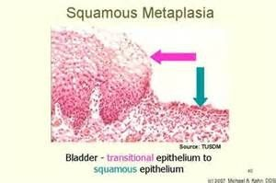
Metaplasia, caught in the act. Bladder transitional epithelium becoming squamous epithelium. Nothing here is malignant — the tissue has swapped one mature, differentiated cell type for another in response to chronic irritation. That is the whole definition: a change in differentiation , not a loss of order. Source: Abnormal Cell Growth for posting.pptx, Slide 5.
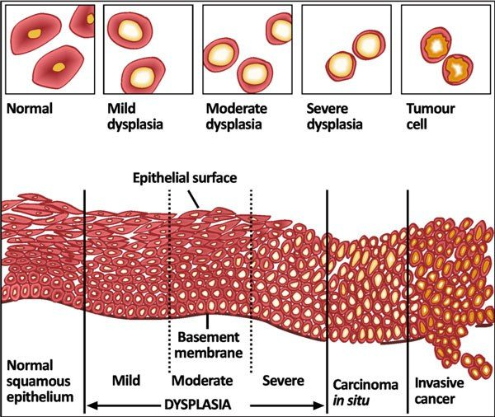
The single most important diagram in this lecture. Read it left to right: normal squamous epithelium, then mild, moderate and severe dysplasia , then carcinoma in situ , then invasive cancer . Notice what changes and what does not. Cells get more pleomorphic and lose their orientation the whole way along — but the basement membrane stays intact until the very last panel. Everything up to and including carcinoma in situ is still above that line , which is exactly what Tis means in the TNM system. Source: Abnormal Cell Growth for posting.pptx, Slide 8.
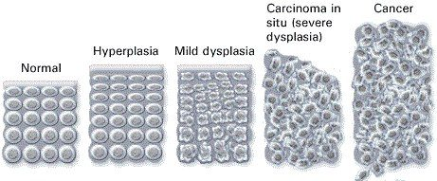
The same progression, counted rather than drawn in section: normal → hyperplasia (more cells, still orderly) → mild dysplasia → carcinoma in situ , labelled here as severe dysplasia → cancer . Hyperplasia belongs on this line and hypertrophy does not: hyperplasia is more cells, hypertrophy is bigger cells, and only one of them is a step towards neoplasia. Source: Abnormal Cell Growth for posting.pptx, Slide 9.

3.3 · Objectives c & k — Neoplasia and histological grading
A neoplasm is an abnormal mass of tissue growing autonomously — self-perpetuating without physiologic growth stimuli. That single word is what separates it from hyperplasia, which stops when the stimulus stops. The entire proliferating population is derived from one cell that underwent a genetic alteration, so a tumour is a clone. It has two components: parenchyma, the proliferating neoplastic cells, and stroma, the connective tissue and blood vessels supporting them. Neoplasm and tumor are interchangeable.
Cancer is a malignant neoplasm. The word comes from the Latin for crab, because it “adheres to any tissue that it seizes upon” and reaches out with claws into surrounding tissue. A metastasis is the portion of a cancer that has migrated from the primary site to other sites.
Grade | Resemblance to the normal cell
Well differentiated | Close resemblance
Moderately differentiated | Intermediate resemblance
Poorly differentiated | Poor resemblance
Anaplasia | Lack of differentiation

Grading and staging answer different questions, and the exam will test that you know which is which. Grading asks what does it look like — how closely the neoplasm resembles comparable normal cells in appearance and function. Staging asks how far has it got — size, nodes, metastases.
 | Benign tumour | Malignant tumour
Border | Well circumscribed | Ragged, not easily discernable
Relation to tissue | Compresses surrounding tissue | Infiltrates and invades it
Capsule | Often has a fibrous capsule | —
Differentiation | Usually well differentiated | Various degrees
Metastasis | Does not metastasize | May metastasize
Growth | Slow | Rapid

Histologically, four features move a tumour along that spectrum: pleomorphism, abnormal nuclei, mitoses, and abnormal differentiation.
Why does a tumour outgrow normal tissue? The deck answers it from stem cell kinetics. A stem cell has unlimited self-renewal and cellular immortality but a relatively low rate of proliferation; once a cell commits to differentiation, proliferation can be dramatic, but those differentiated cells have a limited life-span. Abnormal differentiation in cancer puts a greater percentage of cells in the proliferative pool at the expense of the maturation pool, so the mass grows through a higher proliferative fraction AND a lower rate of cell loss — both halves, not just faster division. The deck is careful to call the cancer stem cell idea a conceptual framework rather than an absolute explanation.

3.4 · Objective d — Routes of tumour spread
Route | Mechanism | Where it goes
Haematogenous | Cells separate from each other and degrade intercellular tissue with enzymes; cells invade the vessel; multiple tumour fragments travel | Typically through veins — especially the portal vein and the inferior vena cava, so cancers often spread to liver and lungs respectively. One organ may carry several nodules
Lymphatic | Cancer spreads into lymphatic vessels at the tumour margin | Follows the natural route of lymphatic drainage — which is why nodal staging is anatomically predictable
Seeding | Invasion of tumour through an organ surface into a cavity | Pericardial, pleural, peritoneal cavities, joint cavities, and the subarachnoid space. Most commonly the peritoneal cavity

A cavity here is defined by the membrane covering the organs in it and the membrane covering the cavity wall — pericardium, pleura and peritoneum over heart, lungs and abdominal organs respectively.
Metastatic spread is NOT random. The deck says so directly, and gives three determinants: the pattern of venous blood flow, specific receptors on tumour and endothelial cells, and metastatic “fitness”, which is genetically determined. Reaching the bloodstream is only the first hurdle — the cell must then achieve survival in the circulation and survival in a new organ.

3.5 · Objectives e & f — Classifying tumours by origin
This is a naming rule, and once you have it, every tumour name in medicine decodes. Two origins, and a suffix for each.
Origin | Benign | Malignant
Mesenchymal — supportive tissue: connective tissue, adipose, cartilage, smooth and striated muscle, bone | Named for the tissue | Sarcoma
Epithelial, glandular pattern or from a gland | Adenoma — sometimes secretes the hormone of its gland of origin | Adenocarcinoma
Epithelial, squamous differentiation | — | Squamous cell carcinoma
Epithelial surface, finger-like projections | Papilloma — visible “finger-like” or warty projections, microscopically or macroscopically | —

Mesenchymal → sarcoma. Epithelial → carcinoma. If you can place the tissue of origin in one of those two buckets, you can name the malignancy. Adipose tissue is supportive, so a malignant fat tumour is a sarcoma, never a carcinoma.

3.6 · Objectives g & h — Gene alterations and chemical carcinogenesis
Carcinogenesis is a multistep process resulting from damage to multiple normal regulatory genes. Those genes may be inherited and/or damaged by chemical carcinogens, ultraviolet and ionizing radiation, or microbial organisms — viruses and a bacterium.
Category | Normal job | What goes wrong | Examples
Protooncogenes | Promote regulated cell growth — growth factors, growth factor receptors, nuclear regulatory proteins, signal transduction proteins | Mutation converts them to oncogenes, encoding oncoproteins that promote continued uncontrolled growth | —
Tumour suppressor genes | Inhibit cell growth | Loss removes a brake | NF-1, NF-2, RB, APC
Repair genes | Promote repair of damaged deoxyribonucleic acid | Loss lets mutations accumulate | BRCA-1, BRCA-2
Apoptosis genes | Cause cells with damaged deoxyribonucleic acid to self destruct | Loss lets damage be continued in dividing cells and become permanent | —

Chemical carcinogenesis has two named steps. Initiation, caused by initiators: chemicals cause permanent damage to deoxyribonucleic acid. Promotion, caused by promoters: sustained or enhanced proliferation of cells already damaged by an initiating agent, raising the risk of successive mutations.
Agent | Source | Cancer
Polycyclic aromatic hydrocarbons | Combustion of tobacco | Bladder and lung — among the most powerful carcinogens known
Aromatic amines | Occupational exposure | Classically emphasised in occupational bladder cancer

3.7 · Objective i — Microorganisms and carcinogenesis
Five organisms, and they divide into two mechanisms. Either the microbe directly disables a tumour suppressor, or it causes chronic inflammation with repeated regeneration and lets mutations accumulate. Sorting them that way turns five facts into two ideas.
Organism | Cancer | Mechanism
Human papillomavirus  types 16 and 18 | Cervical cancer; also anal, vulvar, vaginal, penile, and oropharyngeal squamous cell carcinoma | Direct. Integrates its viral deoxyribonucleic acid into the host genome, causing excessive E6 and E7. E6 blocks p53 (needed to promote self destruction of mutated cells); E7 blocks RB (needed to inhibit cell growth)
Epstein Barr virus | Certain B cell lymphomas and nasopharyngeal carcinoma | Direct. Infects B lymphocytes and “immortalizes” them; also infects oropharyngeal epithelial cells. In normal immune function this does not happen — the patient is asymptomatic or has self-limited infectious mononucleosis
Hepatitis B virus | Hepatocellular carcinoma | Both. Chronic infection and injury → continuous regenerative attempts → cells at risk of mutation. AND it encodes a protein that binds p53. Emphasises: chronic inflammation, regenerative hyperplasia, genomic instability
Hepatitis C virus | Hepatocellular carcinoma | Inflammatory. Chronic hepatitis → repeated cycles of cell death and proliferation. Most arises in cirrhosis, though cancer can occasionally occur without it
Helicobacter pylori  the one bacterium | Gastric adenocarcinoma and MALT lymphoma (mucosa-associated lymphoid tissue) | Inflammatory. Gram-negative, colonizes the stomach → chronic gastritis → atrophic gastritis and intestinal metaplasia. Chronic inflammation raises epithelial turnover and the chance of mutation

Three separate organisms converge on p53 and RB. Human papillomavirus E6 and hepatitis B's encoded protein both take out p53, the apoptosis gate; human papillomavirus E7 takes out RB, the growth brake. If you know what those two proteins do, the viral mechanisms stop being three facts and become one idea told three ways.
And the inflammatory mechanism has a testable consequence: eradicating Helicobacter pylori can reduce the risk of gastric cancer and may induce regression of some early MALT lymphomas. That is the cleanest evidence in the lecture that the chronic inflammation is doing the carcinogenic work.
Radiation gets its own short slide: ultraviolet radiation — UVB — and ionizing radiation.

3.8 · Objective j — Heredity and carcinogenesis
Inherited cancer risk comes through the same gene categories, just present from birth.
Category | Gene | Disease
Tumour suppressor alterations | Rb protein | Retinoblastoma (rare childhood eye tumour) and osteosarcoma
NF-1 and NF-2 | Neurofibromatosis types 1 and 2 — a variety of central and peripheral nervous system tumours
p16 (INK4a) | Malignant melanoma
APC | Familial adenomatosis polyposis — 500 to 2500 premalignant adenomatous polyps in the teens and twenties; colon cancer by age 50
Repair gene alterations | BRCA-1, BRCA-2 | A minority of breast cancer patients carry an inherited mutation
Defective repair genes | Xeroderma pigmentosum — cannot repair mutations caused by UVB; increased skin cancer in sun-exposed areas
Apoptosis gene alterations | — | Inherited failure to make mutated cells self destruct, so mutations propagate

3.9 · Objective l — TNM staging
Staging has three purposes: it indicates the extent of spread within the patient, it determines prognosis, and it guides management. It is based on three things, which are exactly the three letters: the size of the primary lesion, the extent of spread to regional lymph nodes, and the presence or absence of blood-borne metastases.
Letter | Category | Meaning
T — primary lesion | Tis | Lesion has not invaded through the tissue basement membrane; is = in situ
T1–T3 or higher | Increasing size of the primary lesion; increasing depth of invasion
N — regional nodes | Nx | Regional lymph nodes cannot be assessed
N0 | No regional lymph node metastasis
N1, N2 or higher | Involvement of increasing number and range of lymph nodes
M — metastasis | Mx | Distant metastasis cannot be assessed
M0 | No distant metastasis
M1 | Distant metastasis present

The convention generalises: x means cannot be assessed, 0 means none found. And the caveat the deck states outright — TNM definitions are cancer-specific. For some cancers, depth of invasion is more important than size.
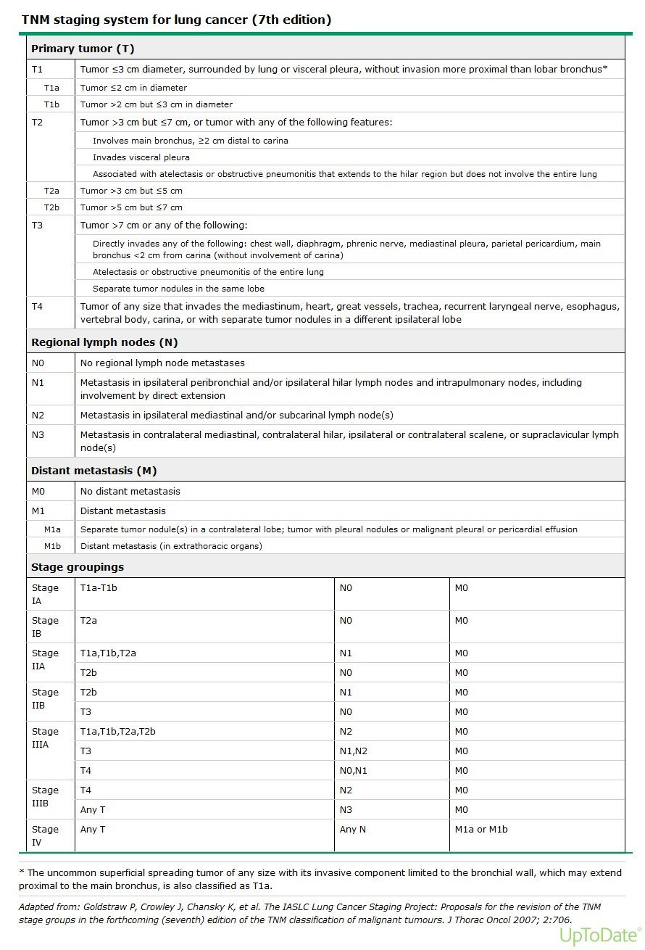
Do not memorise this table. It is here to make one point, which the previous slide states outright: TNM definitions are cancer-specific . This is the lung version, and its T categories turn on distances from the carina and involvement of named structures that mean nothing in, say, colon cancer — where depth of invasion through the bowel wall matters more than size. What transfers is the grammar : T for the primary, N for regional nodes, M for distant metastasis, x for cannot be assessed, 0 for none found. Source: Abnormal Cell Growth for posting.pptx, Slide 43.
Source: Abnormal Cell Growth for posting.pptx (Professor Hugh G. Rappa, MD), Slides 1–43, and the PAJ 5101 syllabus instructional objectives a–l. Figures are reproduced from the lecture slides and each is cited to its slide.

